**Self Evaluation:**

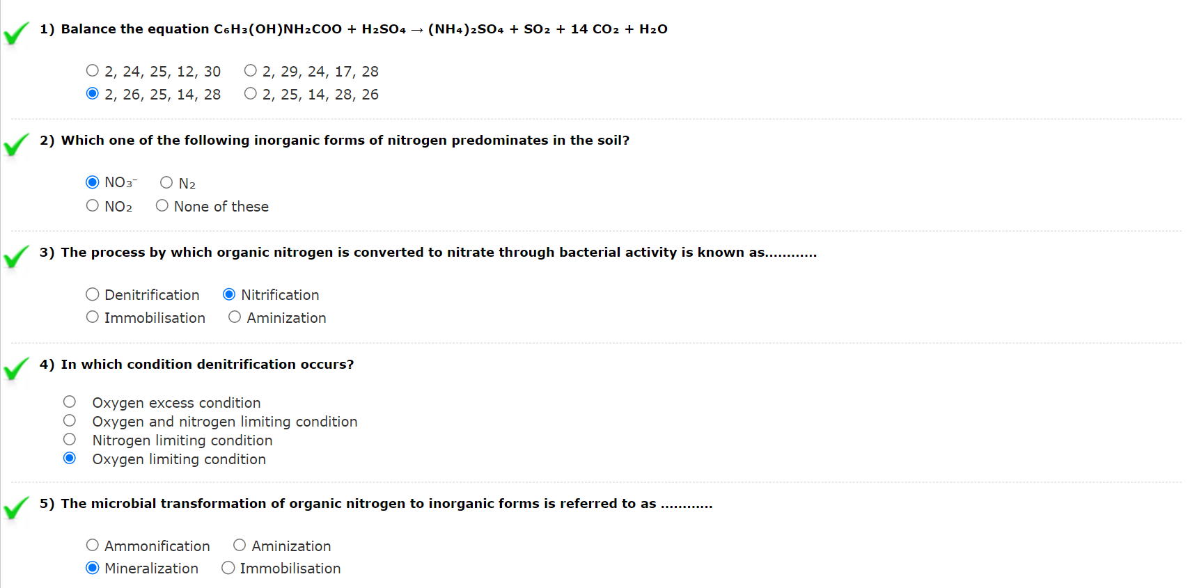

## **Assignments:**

1. Discuss the method of determination of nitrate by selective ion electrodes.

Ans: Solubilized nitrate is determined potentiometrically using a nitrate ion-selective electrode (ISE) in conjunction with a double-junction reference electrode and a pH meter equipped with an expanded millivolt scale (mV), or an ISE meter capable of being calibrated directly in terms of nitrate concentration. Standards and samples are mixed with an ionic strength adjustment solution. Calibration is performed by analyzing a series of standards and plotting mV vs. nitrate-nitrogen concentration on semilog paper, or by calibrating the ion meter directly in terms of nitrate concentration.

1. What form of nitrogen in the soil is determined by the Kjeldahl method?

Ans: Inorganic N ( NH3+, NO3- and NO2- ), Organic N

1. Why is nitrogen essential in the soil? Discuss its deficiency symptoms.

Ans: Nitrogen is so vital because it is a major component of chlorophyll, the compound by which plants use sunlight energy to produce sugars from water and carbon dioxide (i.e., photosynthesis). It is also a major component of amino acids, the building blocks of proteins. Without proteins, plants wither and die. Slow growth and uniform yellowing of older leaves are usually the first symptoms of nitrogen (N) deficiency. Nitrogen-deficient plants produce smaller than normal fruit, leaves, and shoots and these can develop later than normal. Broadleaf foliage in fall may be more reddish than normal and drop prematurely.

1. How can we determine the organic plus ammonium nitrogen from soil? Explain.

Ans: (a) Methods for the determination of ammonia and nitrate in soil are described. The ammonia and nitrate are extracted at pH 1.0–1.5 with a mixture of potassium sulphate and sulphuric acid, and the ammonia is determined by distillation with magnesium oxide at 25°C. in a modified Conway microdiffusion unit. Ammonia plus nitrate is determined on a separate sample of the same extract by reduction of the nitrate to ammonia with titanous hydroxide and subsequent distillation with magnesium oxide, both the reduction and distillation being carried out in a modified microdiffusion unit at 25°C.

(b) The methods are applicable to coloured extracts and are not affected by substances found to interfere with other methods of determining ammonia and nitrate.

(c) It is suggested that the methods may also prove useful for the determination of ammonia and nitrate in plant materials.

1. Discuss about the method determination of potentially active nitrogen in the soil.

Ans: The Kjeldahl method permits the available nitrogen to be precisely determined in the plant and in the soil. The method of determination involves three successive phases which are:

(a) Digestion of the organic material to convert nitrogen into HNO3.

(b) Distillation of the released Ammonia into an absorbing surface or medium.

(c) Volumetric analysis of the Ammonia formed during the digestion process.